**CPCZurich2021 Practical Tutorial I – Metacognition**

**Installation Guide**

**Tutor**: Marion Rouault (marion.rouault@gmail.com), Ashraya Indrakanti ([ashrayai@biomed.ee.ethz.c](mailto:ashrayai@biomed.ee.ethz.ch)h), Computational Psychiatry Course 2021, Zurich, Switzerland.

**Revision and testing**: Inês Pereira (pereira@biomed.ee.ethz.ch)

**PART 1: Main Toolbox Download**

1. Make sure you install MATLAB and that you can open and run it: <https://www.mathworks.com/products/get-matlab.html>
2. Next, check that you have the following two toolboxes: Statistics & Machine Learning toolbox and the Optimisation toolbox.

To do this, open Matlab. You should see something like:

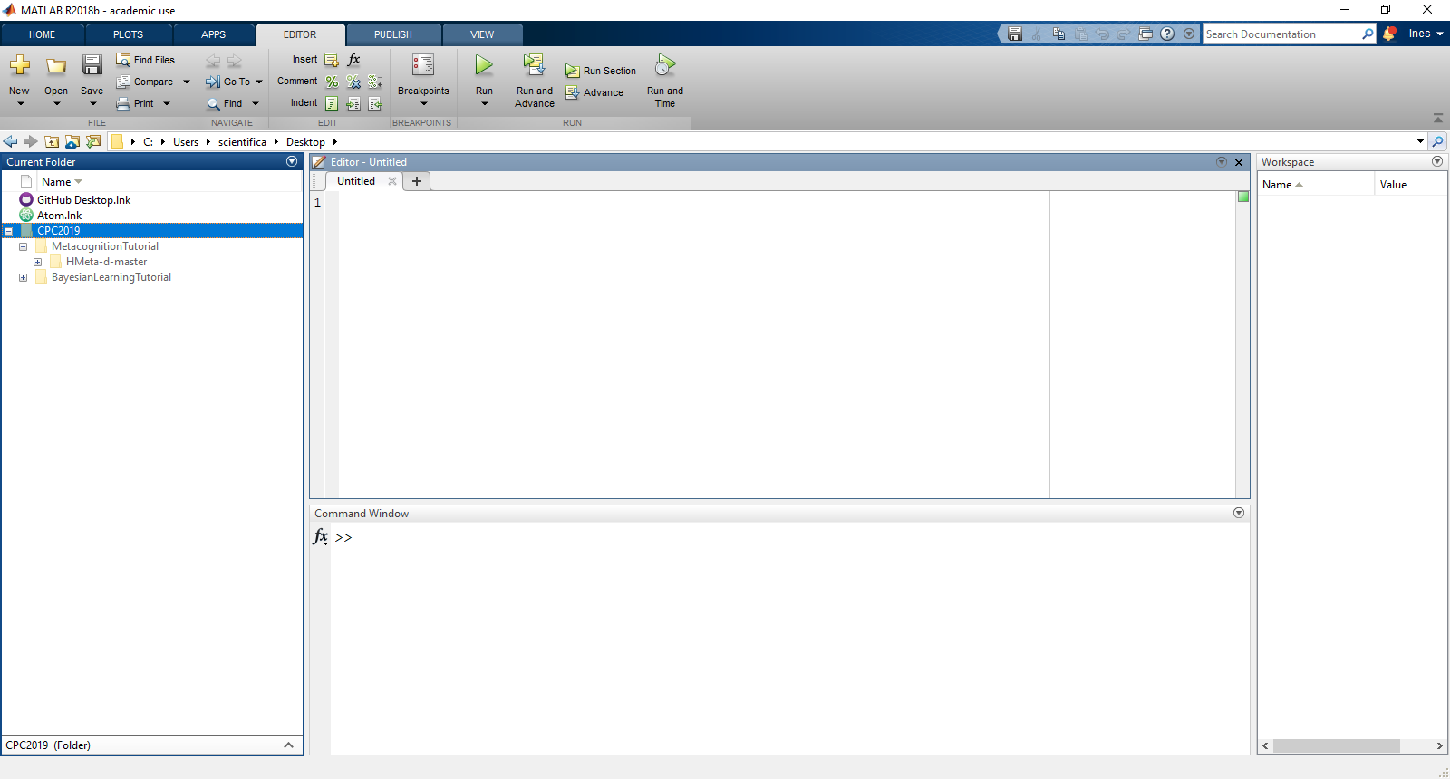

Click on the Home tab. You should see the following options:

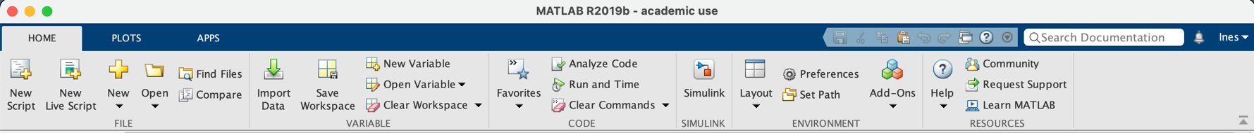

Click on the “Add-Ons”. You should now see a new window similar to the following: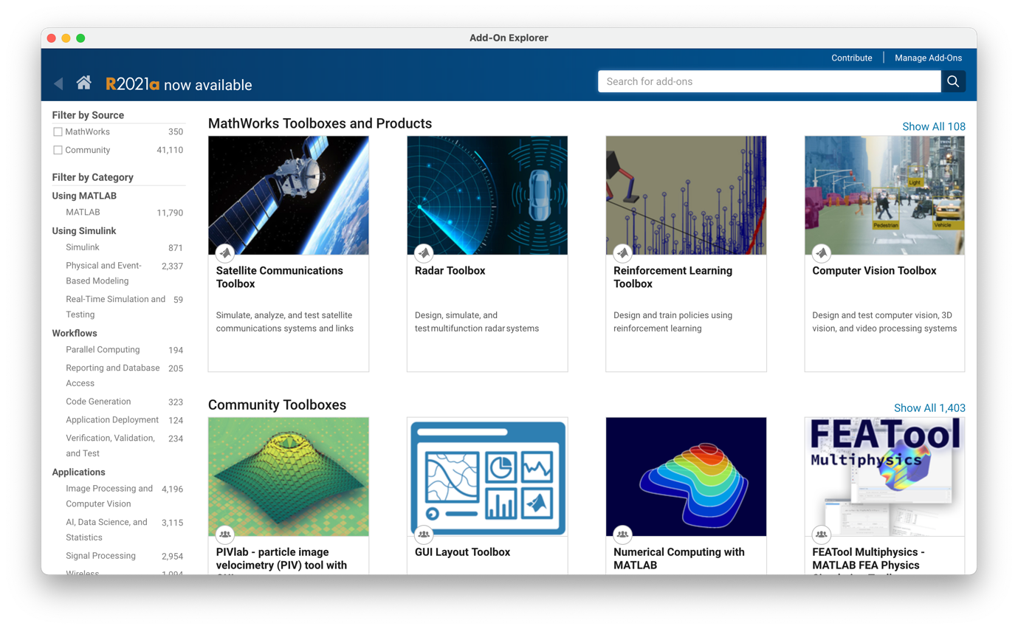

Search the toolboxes you need using the search bar in the upper right corner. You will immediately see whether these are installed. If not, click on the toolbox’s name/thumbnail and follow the instructions to install it.

1. Then go to the Github page of the HMeta-d Toolbox and download the ‘master’ folder (found here: <https://github.com/metacoglab/HMeta-d>)

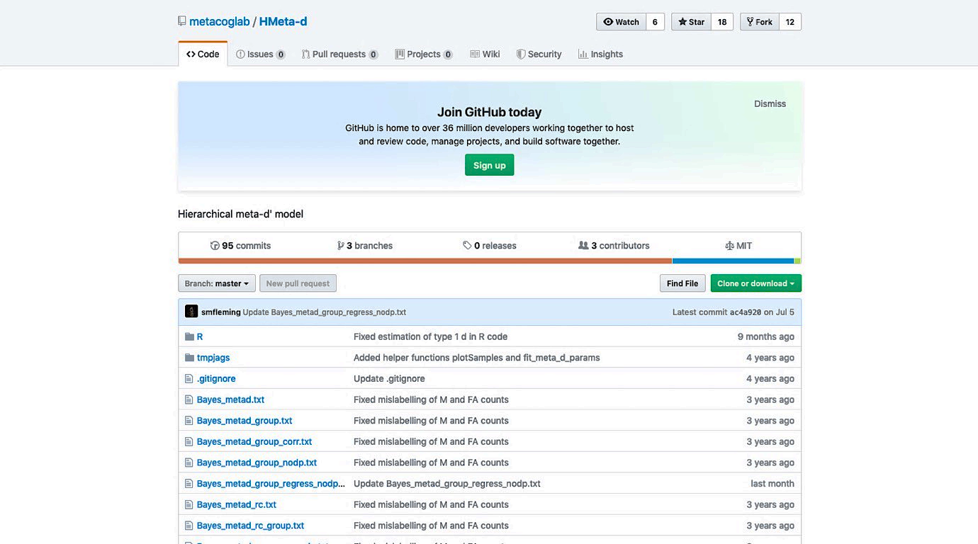

You will be provided with 2 possibilities to download the toolbox:

1. Downloading the Toolbox via .zip File.
2. Cloning the Toolbox. This allows you to keep up-to date with future changes in the Toolbox but is only possible if you have git installed.

For the purposes of this tutorial and if you do not have git, we advise you to use the first possibility and only download the .zip File.

1. Unzip the file and put it in a folder/directory which you will use for the practical tutorial (e.g., Desktop/CPC2021/MetacognitionTutorial).

**Avoid spaces in the titles of your folders**.

1. Now you need to install JAGS (an MCMC package similar to BUGS) on your machine, which can be found here: <http://mcmc-jags.sourceforge.net>

**Note that there are compatibility issues between matjags and JAGS 4.X**. To run the MATLAB code, **you will need to install JAGS 3.4.0** rather than the latest version.

1. **Mac**:
   1. If you follow the above link and click your way through to your operating system, you should land on this page: <https://sourceforge.net/projects/mcmc-jags/files/JAGS/3.x/Mac%20OS%20X/>

**Read the READMe carefully**. JAGS-Mavericks-3.4.0.dmg is suitable for OS 10.9 (Mavericks) or later.

* 1. Download and open the .dmg file. You will see the following window appear:



**The first thing to do is to click on the Readme.rtf and read it. Please follow the instructions carefully.**

1. **Windows:**
   1. Go to: <https://sourceforge.net/projects/mcmc-jags/files/JAGS/3.x/Windows/>.

Try to download the .exe file and open it. An installer will appear and will guide you through the installation. **Note down the destination folder for the installation (default: C:\Program Files\JAGS\JAGS-3.4.0)**. If you do not manage to run exampleFit or exampleFit_group, turn to the instructions below.

* 1. Open Matlab. Navigate to the JAGS folder (default: C:\Program Files\JAGS\JAGS-3.4.0) and add it to your Matlab path by right-clicking on the folder. To do this, use the Current Folder pane on the left of the Matlab GUI.



* 1. Modify your Windows Path environment variable to include the JAGS bin folder. To do this:
     1. Click on the Windows start button and search for “Edit the system environment variables”
     2. Select “Environment variables” (above lower right corner of new window)
     3. Under System variables (the bottom half of the screen), find the row that says “PATH” under the Variable field.
     4. Select the “PATH” row, and click “Edit”.

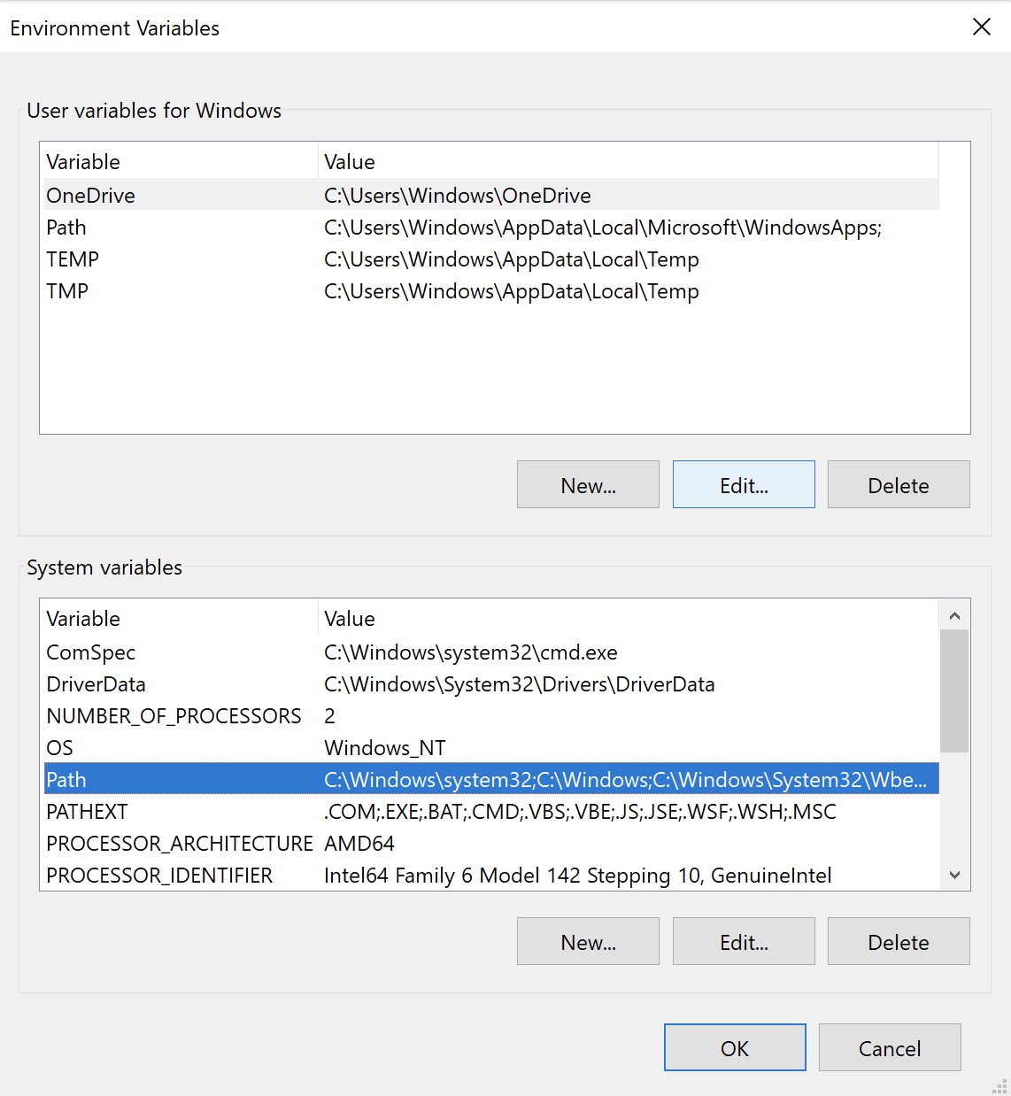

* + 1. Add the path where your JAGS bin folder is installed (default: C:\Program Files\JAGS\JAGS-3.4.0\x64\bin) to the list of PATH variables. **Click OK, and then click OK again in the Environment Variables windows and on the System Properties windows (if you do not click click on the Environment Variables windows, the changes to the PATH variable will not be saved).**
  1. If this still does not solve your problem, go to: <https://sourceforge.net/projects/mcmc-jags/files/Manuals/3.x/>

And download the installation manual. Go to the section on Windows and **read everything before starting to download anything. This will save you lots of time going back and forth because you did not know what the specific instructions were.**

* 1. **There are known issues with the installation on Windows. If you have trouble installing JAGS, do not worry**. You will still be able to follow the majority of the tutorial.

1. Feel free to try the toolbox out by following the tutorial instructions that can be found on the wiki: <https://github.com/smfleming/HMM/wiki/HMeta-d-tutorial>.

In order to run the code, you first need to open MATLAB and in MATLAB navigate to the folder/directory you prepared (e.g., “MetacognitionTutorial”). Then right-click on the directory and “Add to Path”, “Selected Folders and Subfolders”.

To get started, try running exampleFit or exampleFit_group.

Note: This is a great way to test that the version of JAGS you installed runs ☺.

If you have **trouble installing JAGS**, do not worry. You will still be able to follow the majority of the tutorial.

**PART 2: Tutorial-specific files**

Once the tutorial slides and instructions have been finalised, they will be emailed to all individuals who have signed up to the tutorial.

When these files have been received, they will need to be added to the folder you created above (e.g. Desktop/CPC2021/MetacognitionTutorial).

**FINAL NOTE:**

In the tutorial, remember to check that the folder you created containing the HMeta-d Toolbox and tutorial-specific files (e.g., Desktop/CPC2021/MetacognitionTutorial) is added to your MATLAB path (folders and subfolders) ☺.

Well done! You’re all set up for the Practical Tutorial session.

If you have trouble getting to this point before the Practical Tutorial Session, please consult the **#tutorial-helpdesk channel on Slack**. You will be given access to the CPC Slack workspace at the beginning of the course. Check if anyone has had the same issue and has managed to solve it and how. If no one else has encountered the same problem, post your question. **Inês** will be monitoring the channel and providing support. In addition, given the volume of attendees this year, we would be really grateful if you could assist us by answering queries on Slack yourself if you come across a problem you know and have solved.

For those who need more personalized help, Inês will be offering support hours. More information on the exact time will follow.